A step by step guide to Affiliate Window and joining the Myprotein US PT Scheme

Let’s get started…

Welcome to the step by step guide to how to sign up for Affiliate Window and joining the Myprotein US PT Scheme. This guide is full of top tips to help you get started as well as everything you need to know

Stages to complete

- Email barney.woodbridge@thehutgroup.com to receive your invite code to Affiliate Window – this will waive the joining fee
- Sign up to Affiliate Window
- Complete your personal profile
- Provide your payment information
- Email barney.woodbridge@thehutgroup.com to receive your discount codes
- Create tracking links and pass your discount codes onto your clients

Don’t forget, if you have any questions or problems, you can email me at barney.woodbridge@thehutgroup.com

Sign up to Affiliate Window

What you need to do...

Sign up as a Publisher with Affiliate Window using this link:
https://darwin.affiliatewindow.com/user/affiliate-signup/account-details

Then complete the four sections:

- Account Details
  - Basic details about you and where you are in the world.
- Promotional Details
- Set your ‘Primary Region’ as the country in which you operate.
- Select ‘Content’ and then ‘Editorial Content’, before selecting ‘Set as Primary’.
- Website Campaign
- Add your site URL (this can be a Facebook/Twitter page or blog).
- In the ‘Description’, enter Myprotein PT.
- In ‘Sectors’, select ‘Retail and ‘Shopping’, and then ‘Health & Beauty’.
- Verification Method
- Select ‘Yes’ when asked if you have an invitation code.
- Use the invite code provided to you after emailing barney.woodbridge@thehutgroup.com to waive the joining fee

That’s the first step done!

It will take up to 10 days for you to be approved onto the network, but it is usually a lot quicker. If you have any concerns about the approval, just drop me an email.

Complete your profile

Why is this important?

This makes your approval onto the network quicker so the more information you can provide, the better.

Log-in into Affiliate Window using the email address you signed up with and the password you selected.

Hover over the ‘Account’ tab, and select the ‘Overview’ option, shown below.

You will see a checklist of tasks that you need to complete - don’t worry about uploading your profile picture, however, in the ‘Description’, please enter ‘Myprotein PT’.

P Provide Payment Information

Providing your payment information is necessary for receiving your commissions.

Hover over the ‘Account’ tab, and select ‘Payment’ under the ‘Settings’ option, shown below.

Please note, you only need to select ‘VAT registered’ if you are a registered business.

Provide Payment Information

Select the Frequency you wish to be paid (Myprotein US only pays out once per month)

Payments are made on the 15th of the month.

Please bear in mind that we have a 30 day validation period to allow for cancellations and returns. Any valid sales that have not been cancelled or returned are eligible for commission. Please be aware sometimes payment can take up to 45 days on top of the validation period in order to allow for finance payments to be made.

Select a payment threshold – this is the amount of commission you will need to earn before you receive payment.

Then enter your payment details.

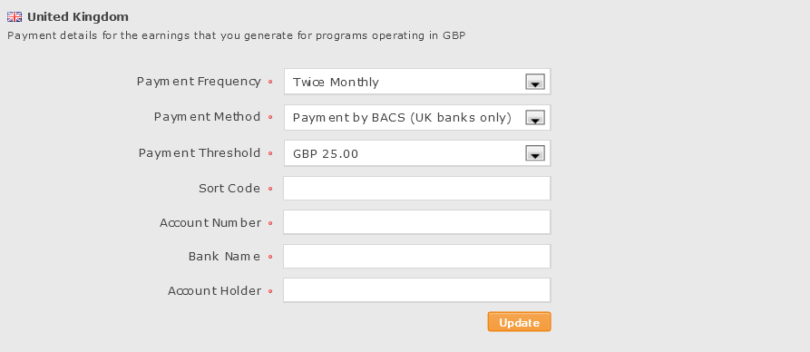

Once your application is complete, you will receive an email confirmation and then be invited to log-in to the Affiliate Window platform. Once logged in, a 6 digit ID will be displayed in the top right of the screen – please email this to barney.woodbridge@thehutgroup.com when requesting your discount codes.

In order to request your discount codes, please email barney.woodbridge@thehutgroup.com

Now you’re ready to get started…

This section takes you through how to find everything you need to get started on Affiliate Window.

Here is what we cover in this section:

- How to create a tracked link in Affiliate Window
- Google Chrome Extension - MyAW

How to create a tracked link in Affiliate Window

So you can earn a commission, each link that you use needs to be a tracked or deep link to ensure it includes the Affiliate Window tracking data. These are easy to create, just follow our step by step guide below.

- Login to your account and click on ‘Link Builder’ from the ‘Links & Tools’ drop down menu.

- Select who you want to create a link for (MP US PT Scheme) from the advertiser drop down where it says ‘PLEASE SELECT’.

- Once you’ve updated the advertiser, the deep link box will update with the html.

- Change the format to ‘URL’ and it will update the deep link. Select for the window to open in a ‘New’ one.

- Just copy and paste the link from the site you want to track into the ‘Deep link url’ box, and this will create a tracking link for you in the ‘Your Deep Link’ box. You can either copy and paste this url as you would normally do with a regular link or you can click ‘Create Shortlink’ and it will make a shortened url that hides the tracking and can also be used for Facebook/Twitter posts but still track sales for you. We personally recommend you use a shortlink of some sort.

- Just copy and paste the shortened deep link to wherever you want to promote it e.g. on your site, on social media.

Google Chrome Extension – MyAW

Affiliate Window have released a new Google Chrome extension for publishers, MyAW. This is a great tool which will save you plenty of time.

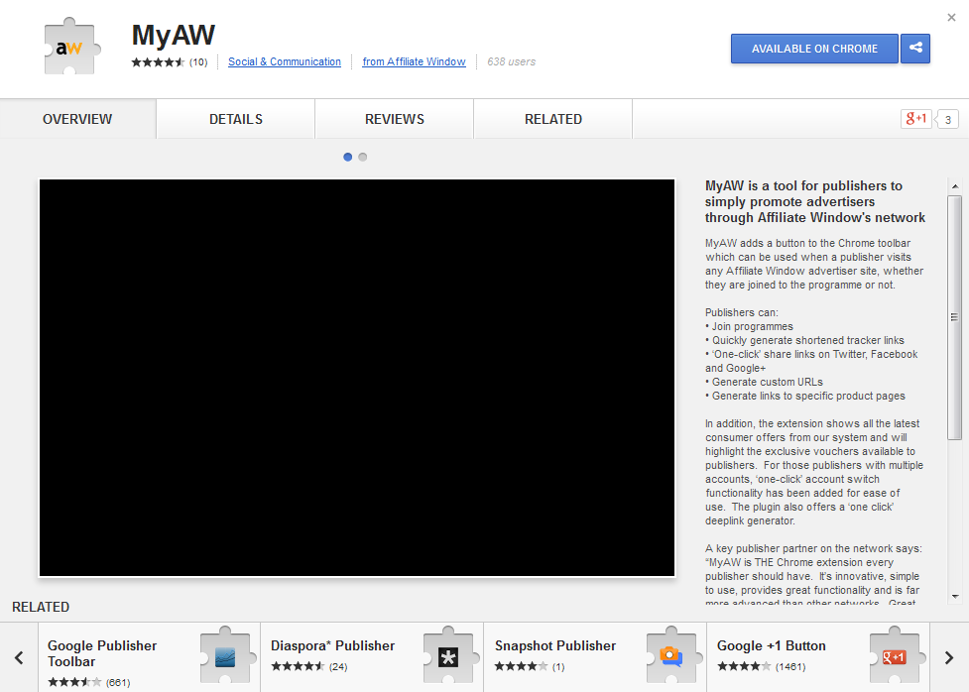
This tool will allow you to:

- Quickly generate shortened tracker links
- 'One-click' share links on Twitter, Facebook and Google+
- Generate custom URLs
- Generate links to specific product pages

- Simply visit the Chrome store using the link below
to download the free extension and get started.

- Link: chrome.google.com

For further information, help or to set up your PT referral discount codes please contact:

Barney Woodbridge at barney.woodbridge@thehutgroup.com

F.A.Q’s

How do I contact the Myprotein US PT team?

Simply email barney.woodbridge@thehutgroup.com

Is the program right for me?

The PT program is designed for any sports professional who engages with clients, friends or interested potential customers.

How do I get the most of the PT program?

We want to work in partnership with all our motivated community and reward you for the advertising and sales you create. We are here to provide you with the up to date latest offers, incentives, and news direct from Myprotein HQ, but we are also here to listen to your ideas and comments. If you have a good suggestion we will try to reward you, plus, what’s the worst that could happen?

How do I add my payment details?

Log in to your account on Affiliate Window and select the ‘Account’ tab. Here you can create or update your payment details.

- To update your bank account / cheque payment and VAT registry details in your account – click on Settings
- Click on Payment
- If you are VAT registered select Yes from the dropdown box – otherwise choose No
- You will need to provide your VAT registration number and registration date
- We are unable to pay VAT to businesses not registered in the United Kingdom
- Select whether you wish to be paid by BACS, cheque or International Wire Transfer and update your details as required
- Click Update to save your changes
- All updates take 24 hours to be validated

How often will I get paid?

Please be aware that sales are tracked and validated monthly allowing for a 30 day cancellation and returns policy. Any valid sales that have not been cancelled or returned are eligible for commission and will then be calculated according to the amount of unique code usages from our PT portal. Please be aware sometimes payment can take up to 45 days allowing for sales to be validated and finance payments to be made.

How do I update my contact details?

- Log in to your affiliate window account. Click on ‘Account’ and under ‘Settings’ you will find ‘Contact Details’.
- Here, you can add or change your email address, mobile phone number and instant messenger contact details as you require.
- Click ‘Update Details’ to save

For explanation of any further details on your account profile please see the Affiliate Window WIKI resource here:
http://wiki.affiliatewindow.com/index.php/Creating_a_Publisher_Profile

